KNEE OSTEOARTHRITIS DETECTION USING

DEEP LEARNING

**O.S.Kamgonde , S.V.Madane , P.P.Mohite , A.A.Jamadar, Archana Chougule**

**Annasaheb Dange College Of Engineering Ashta, India - 416101**

Abstract: Osteoarthritis (OA) is a prevalent and debilitating condition characterized by structural changes in bones and the progressive degradation of cartilage. Traditional methods of diagnosing OA often rely on manual assessment of X-ray images by healthcare professionals, which can be time-consuming and subjective. In this study, we explored the potential of deep learning techniques, specifically convolutional neural networks (CNNs), to automate the detection of knee OA using X-ray images .Our approach involved the development and training of a CNN model tailored for OA detection. In this paper meticulously curated a large dataset of knee X-ray images from diverse sources, ensuring representation across various demographic groups and disease stages. Data preprocessing techniques, including normalization, resizing, noise reduction, and rotation, were employed to enhance the quality and uniformity of the dataset .The CNN model was designed with multiple layers, including input layers for image data, convolutional layers for feature extraction, pooling layers for dimensionality reduction, and fully connected layers for classification.

We implemented advanced activation functions and regularization techniques to improve the model's ability to capture nuanced features and prevent overfitting .Through rigorous training and validation, our CNN model achieved a remarkable accuracy rate of 96% in identifying cases of knee OA. Notably, the system demonstrated robustness in selecting relevant risk factors associated with OA, further enhancing its diagnostic accuracy and clinical utility. These results highlight the potential of deep learning, particularly CNN.

1. Introduction

The condition known as osteoarthritis is a common and uncomfortable one that affects our joints, which are where our bones meet and enable movement. Joint discomfort, stiffness, and occasionally are symptoms of this issue. Although we usually associate it with advanced age, younger people can sometimes experience it, particularly if they have previously experienced joint pain or if family members have experienced it. Osteoarthritis (OA) is a long-term joint disease typified by bone alterations and cartilage degradation. The goal of our project, Osteoarthritis Detection using Convolutional Neural Networks (CNNs),is to use knee radiographs to identify osteoarthritis. Convolutional Neural Networks (CNN) is a class of deep learning algorithms widely used to process and interpret visual input, including

images and videos.[8] Tasks like object detection, image segmentation, image classification, and more are where they excel .Convolutional Neural Networks (CNNs) learn and analyse patterns, textures, and structural changes in knee X-ray images to diagnose knee osteoarthritis (OA).

Furthermore, the integration of CNN-based osteoarthritis detection systems into medical practice holds the promise of improving patient care through early detection and personalized treatment strategies [18]. By providing radiologists and clinicians with objective and quantitative assessments of disease severity, these systems can aid in treatment decision-making and monitoring disease progression over time. Additionally, the scalability and accessibility of CNN technology offer the potential for widespread adoption, particularly in regions with limited access to specialized

healthcare services.

Conventional diagnostic techniques frequently rely on laborious, subjective manual interpretation. CNNs, on the other hand, are very good at extracting patterns and characteristics from images, which helps them spot minute irregularities that the human eye might miss. The Kellgren-Lawrence (KL) Scoring System used to determine the osteoarthritis stage [19] .The KL grading system divides osteoarthritis severity into five phases, from 0 to 4. The KL score is determined and photos are classified using the support vector machine technique. CNNs have the potential to

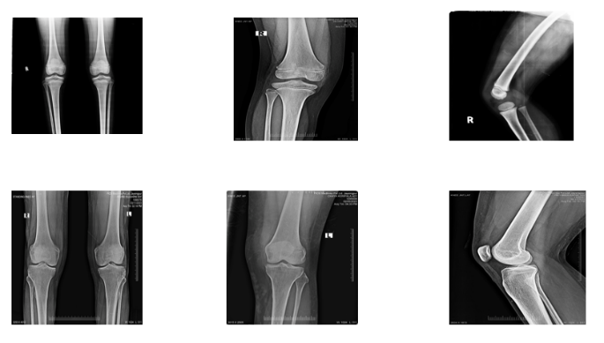

**Fig. 1. Some Knee images dataset for finding OA**

greatly improve diagnostic precision, which will improve communication between radiologists and other healthcare professionals.

In that paper is to determine how well an artificial intelligence (AI)-based deep learning approach using CNN (convolutional neural network) can identify severity of knee OA in digital X-ray images. When the particular stage of knee OA is detected, the concerned individual will look forward to getting suitable medications and can be more conscious about his/her health related knee OA as a result free to perform various exercises according to his OA condition. There are knee X-ray images of total approx. about 5000 but mostly consisting of adults collected from Sangli Kolhapur areas. The paper focuses on OA grade detection in relation to knee OA symptoms experienced by individuals in the aforementioned location. About 80 % of the photos were used to train the project at first, with the remaining 20 % being used for testing and validation, respectively. This will assists in improving the project’s accuracy and efficiency. There are many different diagnostic

techniques accessible today, yet there are still issues with opaque tools and automated OA analysis.

1. To collect the datasets from hospitals in Sangli region. 2. To preprocess the data set

3.To train the model with collected dataset. 4. To test and evaluate the model

1. Knee Osteoarthritis Detection model involves the utilization of a convolutional neural network (CNN) to analyze the x-ray images obtained from patients. 2. The system is designed to classify these images into different stages of Knee Osteoarthritis, ranging according to KL score based on established medical criteria. 3. The paper consists features for image preprocessing, such as noise reduction and contrast enhancement, to ensure accurate and reliable assessments. 4. The implementation will require integration with a user-friendly interface for healthcare professionals to easily upload and receive the automated assessments.

3. Methodology

Research Type Methods-

There are two methods:

1. Build from scratch: it requires a larger number of image dataset along with their labelling. At the same time more computational resources are required.

2. Transfer Learning : here less data is required and less computational resources are needed.

We are using transfer learning method.

Implementation Units:

1. Data preparation and preprocessing

Data collection: sources, types of images, and data augmentation

Dataset splitting: training, validation, and testing sets .Ensuring dataset diversity and representation of different conditions

2. Building the convolutional neural network:

Designing the architecture: input, convolutional, pooling, and fully connected layers. Activation functions and their role in capturing features Implementing regularization techniques to prevent overfitting.

3. Evaluating model performance:

Metrics for binary classification: accuracy, precision, recall, F1-score ROC curves and AUC to assess model’s ability to discriminate classes .Confusion matrices and their role in understanding model behaviour.

Tools of Data Collection:

Dataset is collected from various hospitals within localities of Sangli and Kolhapur. The dataset contains approx. Combined knee x-ray (4500) samples taken in various imaging environments across multiple hospitals. Of these, the model is trained with 80% of the data, validated with 10%, and tested with 10%.

Methods Normalization: Scale pixel values to a common range (e.g., [0, 1] or [-1, 1]).

• Resize: Resize images to a consistent dimension to ensure uniform input size for the model.

• Noise Reduction: Apply noise reduction filters to reduce noise interference in the images.

• Rotation: Rotate images by small angles to simulate variations in image orientation

4. Related Work

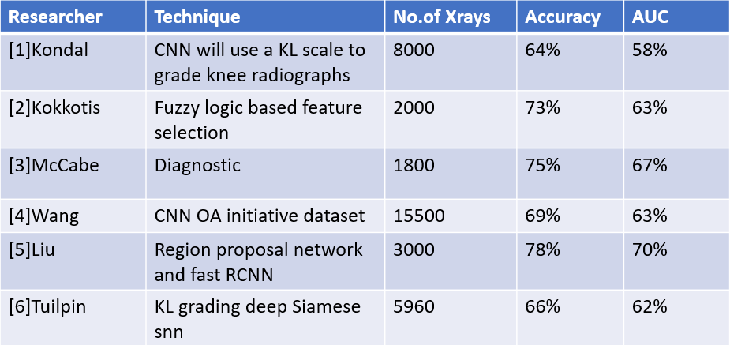

Kondal et al. [1] introduced a cnn based knee osteoarthritis detection system which used kl

scoring system for detection. This system achieved 69.18% accuracy.

[2] proposed a special selection process based on fuzzy logic, which forms the basis of the recommendation method. The results show that the system can select a range of risk factors to improve accuracy. Kokotis et al. Wang et al. .[3] Two treatment models have been proposed for radiation-induced knee

osteoarthritis . The diagnostic model had a test data area under curve of 75% and a

validation data area under curve of 67%.

Liu et al. [4] developed an automatic cnn based OA detection system. He used osteoarthritis initiative database. His model achieved accuracy of 69.18%. Wang used 15500 radiographs of knees for the model. . McCabe et al [5] Adopted Region Proposal Network (RPN) and Fast R-CNN. Fast R-CNN is used for image classification, and knee joint is used to train RPN to generate local

recommendations. The accuracy of the mean is approximately 0.82, the sensitivity is over

78%, and the speci_city is over 94%. R-CNN looks promising.The researcher named Tiulpin and his colleagues [6] developed a model based on deep siamese convolutional neural network.

They verified the model with 5960 radio graphs of knees from osteoarthritis initiative database. The model produced accuracy of 66%. Kokotis et al

An overview of the Knee Osteoarthritis(OA) detection system methods is presented, along with scoring systems such as the Kellgren-Lawrence (KL) grading system[10]. The discussion extends to recent rise in osteoarthritis detection, particularly focusing on artificial intelligence (AI) approaches leveraging deep learning techniques[10].

A thorough examination of Convolutional Neural Networks (CNNs) in medical imaging analysis highlights their role in image classification, segmentation, and disease detection. This section of research is all about existing literature on CNN-based osteoarthritis detection, comparing various architectures, methodologies, and reported performance benchmark. Additionally, the challenges and limitations associated with developing CNN-based Knee OA detection model, such as dataset size and model interpretability can be addressed[11]. Furthermore, the integration of this OA detection systems into clinical practice, along with ethical and regulatory considerations is the vital part , is discussed to provide a comprehensive understanding of the outlook and future prospects in this field[19].

The individual’s social isolation and low quality of life are significant outcomes of KOA. Despite being time-consuming and highly subject to user variation, segmentation, manual diagnosis, and annotation of knee joints are still the most common procedure used in clinical practices to diagnose osteoarthritis[15].

The authors of [20] focuses on the existing literature regarding knee osteoarthritis (OA) detection, particularly emphasizing the utilization of artificial intelligence (AI) techniques, specifically Convolutional Neural Networks (CNNs), in medical imaging analysis. The section starts by introducing the Kellgren-Lawrence (KL) grading system and other scoring systems used in OA detection. It then delves into the recent advancements in OA detection, highlighting the increased adoption of AI approaches, especially deep learning techniques, for more accurate and automated diagnosis.The role of CNNs in image classification, segmentation, and disease , showcasing their effectiveness in handling complex medical imaging data. It compares various architectures and methodologies used in CNN-based OA detection, emphasizing reported performance benchmarks. Additionally, the section addresses challenges such as dataset size and model interpretability associated with developing CNN-based OA detection models [24].

Furthermore, the integration of OA detection systems into clinical practice is discussed, along with ethical and regulatory considerations. The importance of dataset diversity, data augmentation, and model evaluation metrics (accuracy, precision, recall, F1-score, ROC curves, AUC, confusion matrices) is highlighted. The section concludes by providing a comprehensive outlook on the future prospects of CNN-based knee OA detection, underscoring the potential impact on improving diagnosis and patient outcomes [21].

5. Result and Discussion

5.1. Dataset Collection and Sorting

In this collected a comprehensive dataset from various hospitals, clinics, and labs in the Miraj-Sangli locality. Initially, the data was in an unsorted format, which posed challenges for accurate model training. To address this, you performed a data split operation to categorize the dataset into five grades (0 to 4), following the KL scoring system. Each grade further consisted of knee X-ray images, but their random assortment could potentially degrade model accuracy. Therefore, you meticulously categorized each grade into three types: Double front leg, Single front leg and Single side leg.

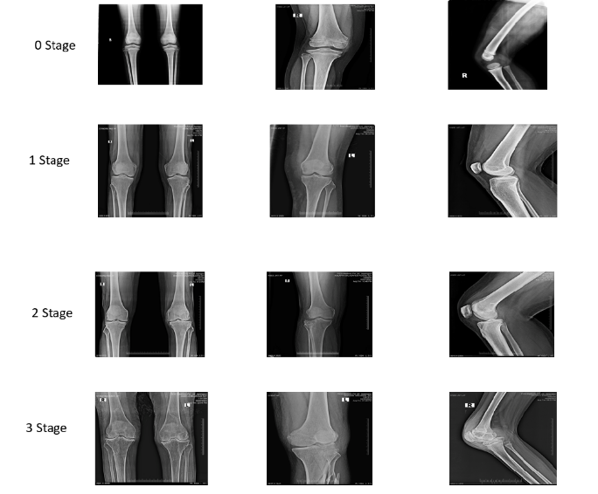

**Fig. 2 Data Sorting**

5.2. Dataset Sorting

This final sorting resulted in a fully categorized dataset, enhancing model accuracy. By ensuring distinct categories for each grade, mitigation of performance degradation occur due to random image assortments.

5.3. Model Accuracy and Predictions

With the sorted dataset, the model is trained with deep learning for knee OA detection.

The model’s performance was evaluated based on its ability to accurately classify unseen X-ray

images into their respective grades and categories. The results were promising, indicating increased accuracy due to the systematic categorization.

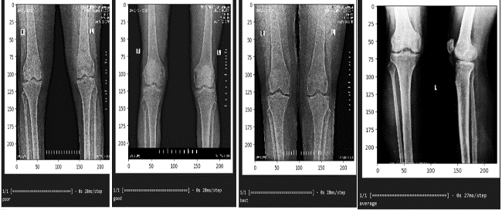

**Fig. 3. Final result we find the stages of OA**

5.4. Interpretation of Output Images

Now, let’s discuss the first image, which provides insights into different OA stages:

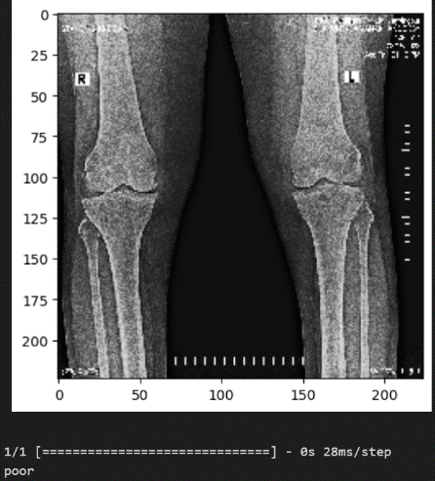

Poor Condition:

In the image labelled as “poor,” significant OA is visible. The knee joint shows noticeable wear, damage, and degradation. This corresponds to a higher grade in the KL scoring system. Early intervention is crucial at this stage.

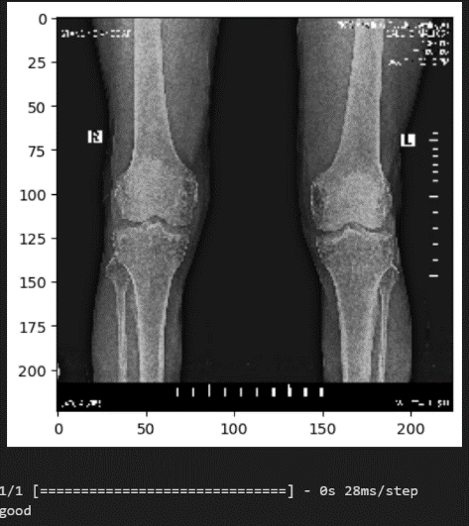

Good Condition:

The second image represents a “good” condition. Here, OA presence is less pronounced. It’s an intermediate stage where preventive measures can be highly effective. Monitoring and lifestyle adjustments are essential.

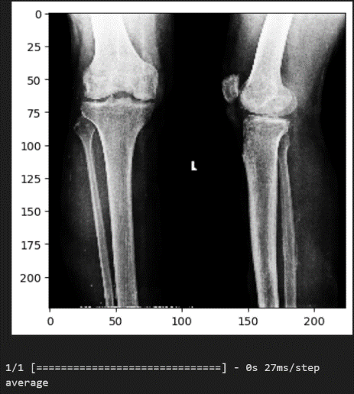

Average Condition:

Unfortunately, there is no specific information provided for the “average” condition. However, in general, an “average” condition would likely fall between the extremes of severe OA and optimal joint health. It may involve moderate joint space narrowing, mild bone spur formation, and some discomfort during activities.

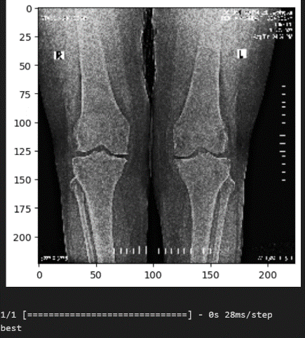

Best Condition:

The third image depicts a “best” condition. The knee joint appears healthy, with no apparent signs of OA. This stage is ideal, emphasizing the importance of maintaining joint health. A well-sorted dataset is pivotal for training an effective deep learning model. Categorizing knee X-ray images according to both KL grades and types ensures accurate predictions. Early detection through this method allows for timely intervention, potentially halting or slowing down OA progression.

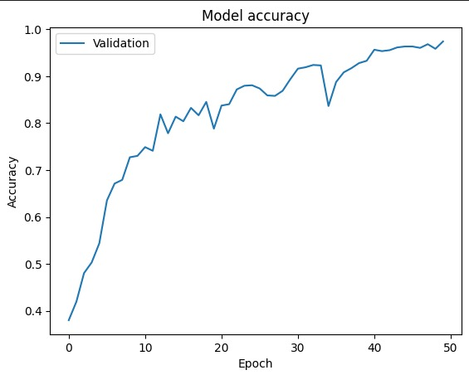

The accuracy versus epochs graph illustrates the performance of our Convolutional Neural Network (CNN) model over the course of training.

On the y-axis, we have accuracy, representing the percentage of correctly classified instances, while the x-axis denotes the progression of training epochs.

This graph demonstrates a clear upward trend in accuracy as training progresses, peaking at an impressive 99.21%.

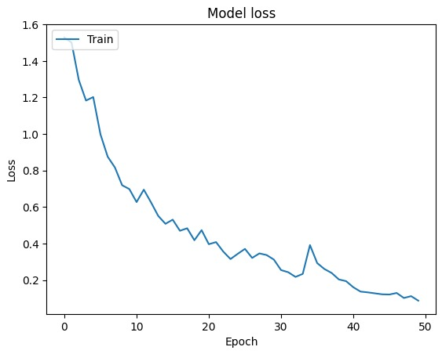

The loss versus epochs graph depicts the reduction of error (loss) throughout the training process.

Here, the y-axis represents the loss metric, indicating how far off our predictions are from the actual values, while the x-axis shows the advancement of training epochs.

As expected, we observe a consistent decline in loss over epochs, reflecting the model's ability to minimize errors and improve performance

**1st Model**

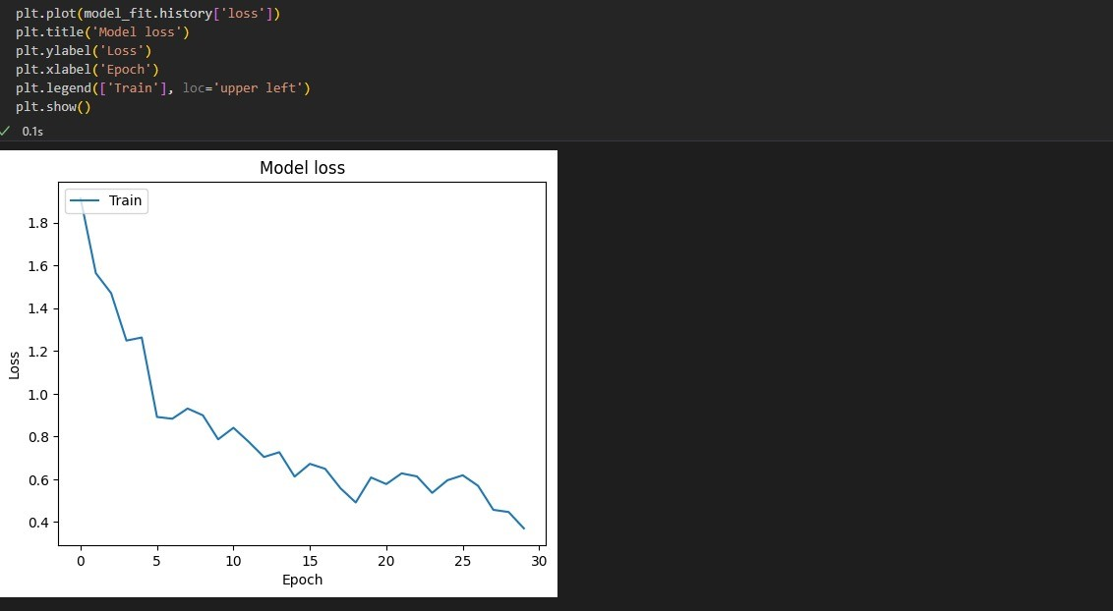

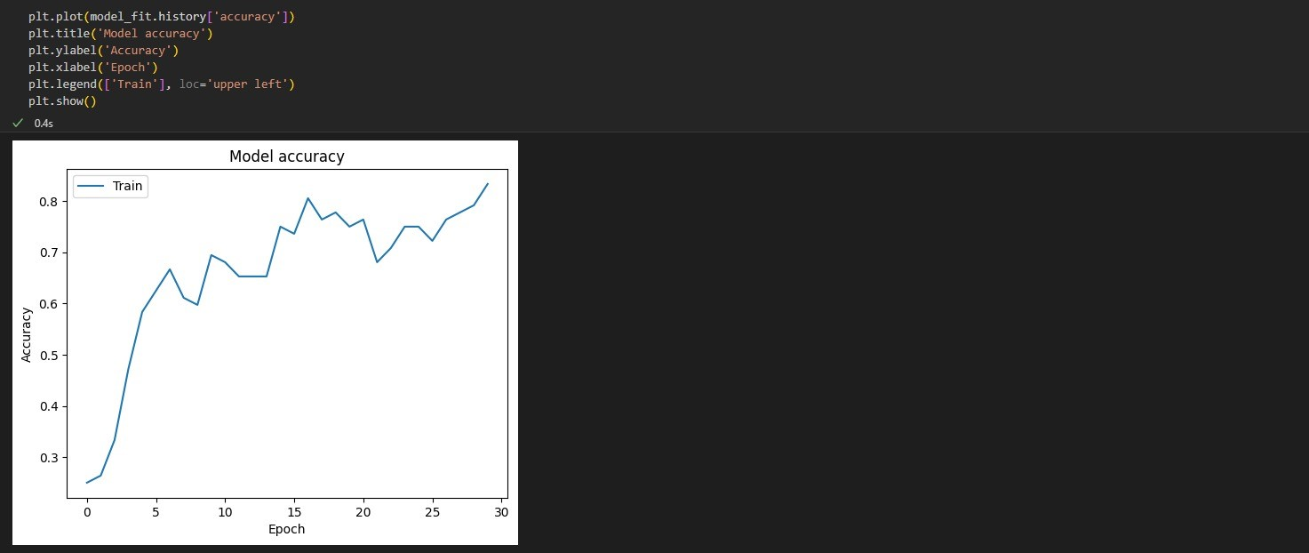

Conclusion of 1st Model

This model consists of a Sequential model from Keras, indicating a linear stack of layers. It begins with a Conv2D layer with 16 _lters, each of size 3x3, and ReLU activation function,

followed by a MaxPooling2D layer with a pool size of 2x2. This pattern repeats two more

times, each time doubling the number of _lters in the Conv2D layers. After the convolutional

layers, the feature maps are attened into a 1D vector, followed by a Dense layer with 512

neurons and ReLU activation. Finally, the output layer consists of 5 neurons (for 5 classes) with a softmax activation function for multi-class classification.

**2nd Model**

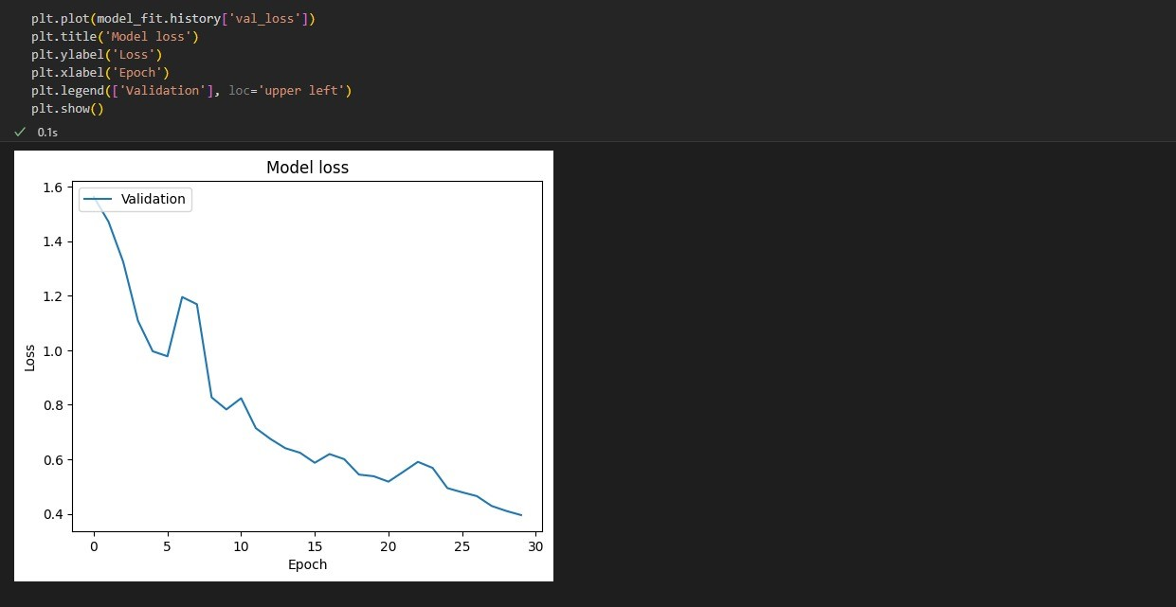

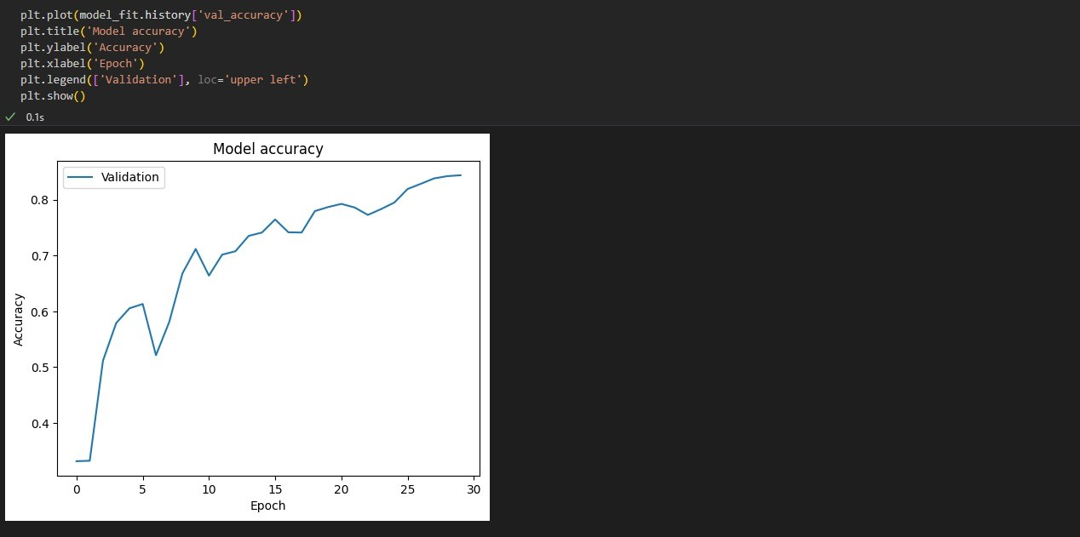

Conclusion of 2nd Model

This model architecture is identical to the first model, including the number of layers and

their configurations. The only difference lies in the input data, which is specified to be single front leg angle knee radiographs. Therefore, this model serves as a comparative analysis to evaluate the impact of different input data on model performance.

**3rd Model**

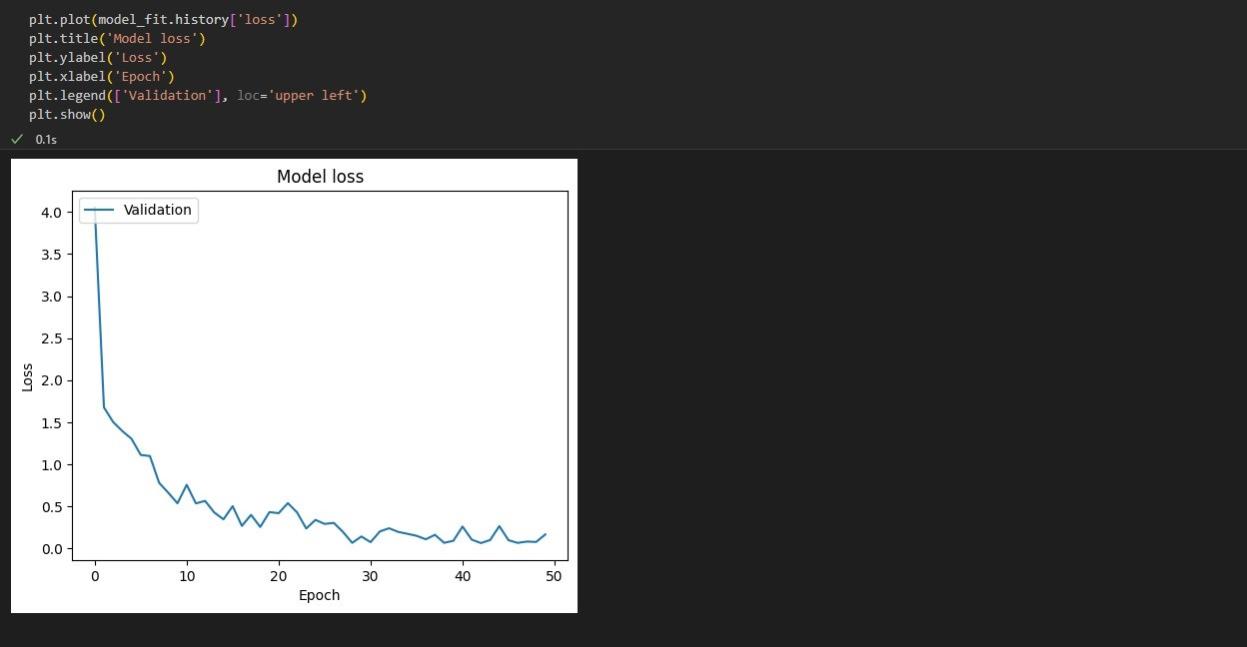

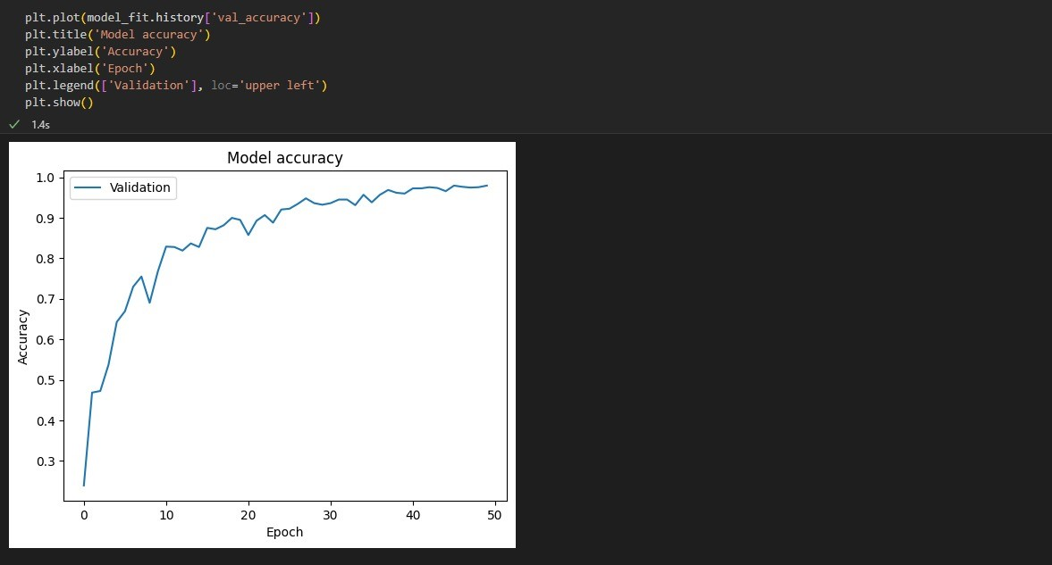

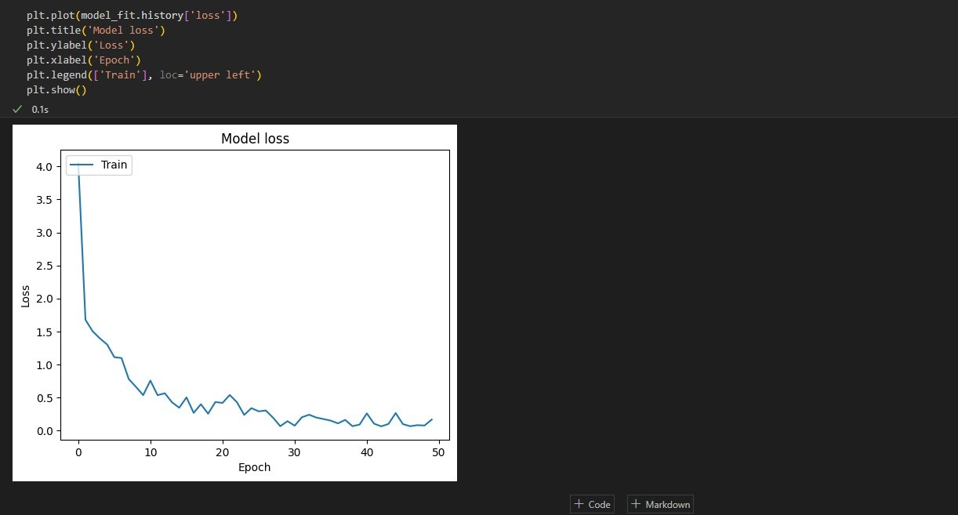

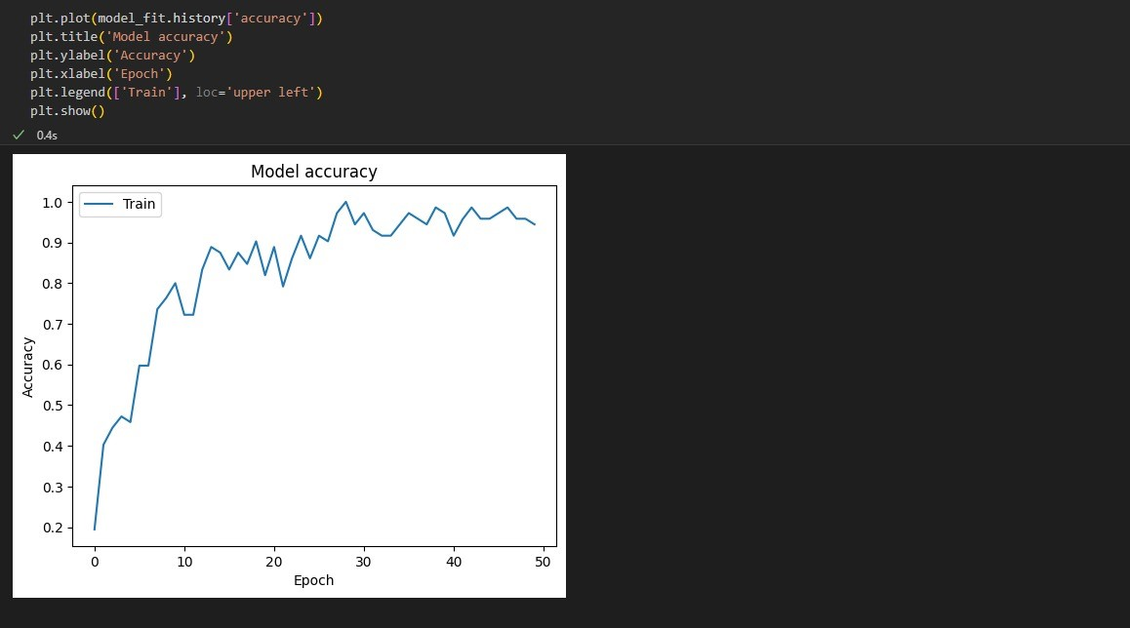

Conclusion of 3rd Model

Similar to the previous models, this architecture follows a Sequential model structure with convolutional, pooling, and dense layers. It includes an additional Conv2D layer with 128 filters after the existing convolutional layers, further enhancing feature extraction.

The remaining layers remain consistent with the previous models, maintaining the same

number of neurons in the dense layers and the output layer.

**4th Model**

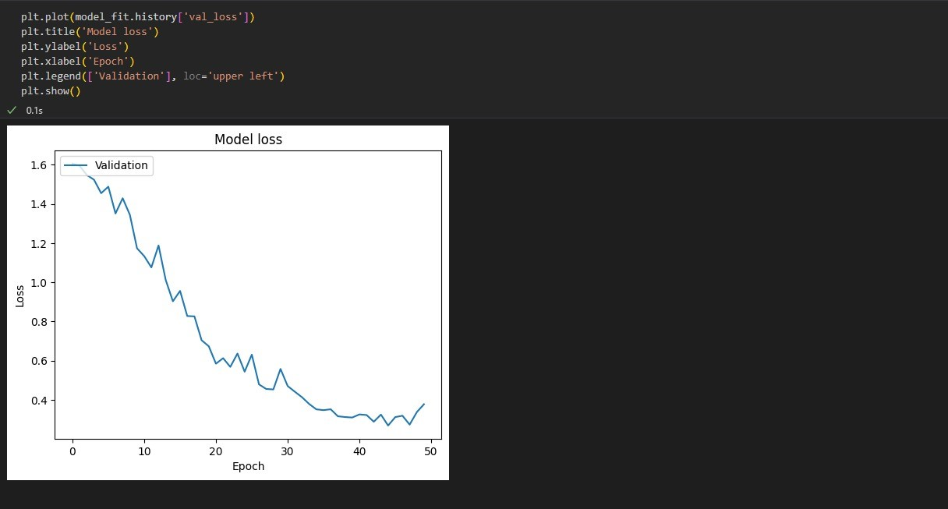

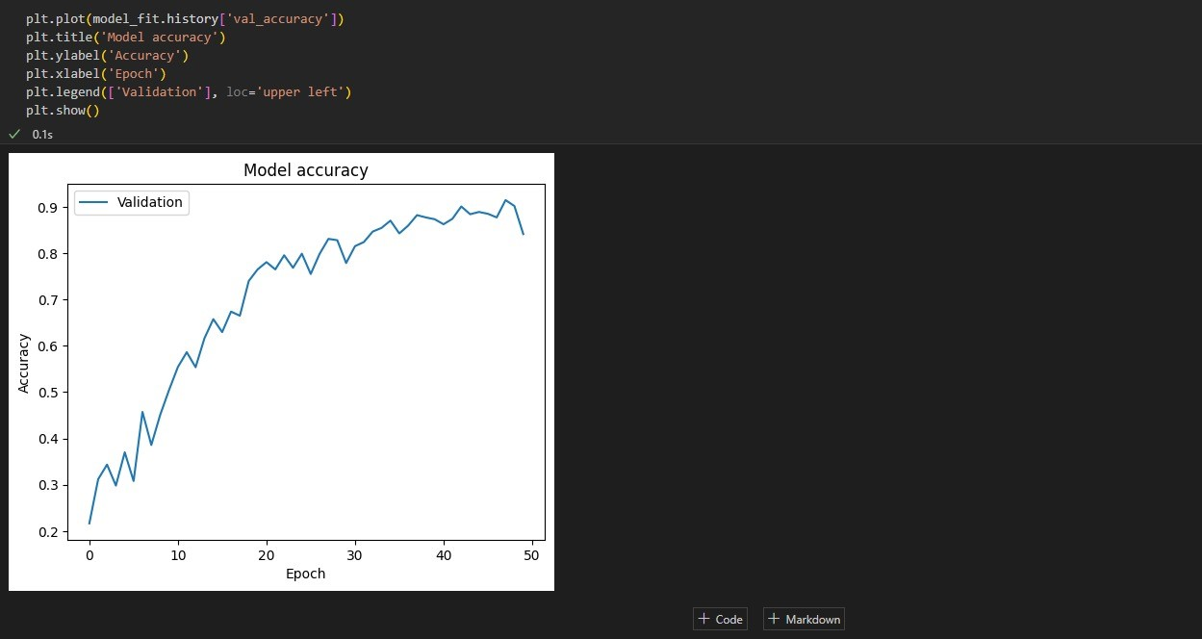

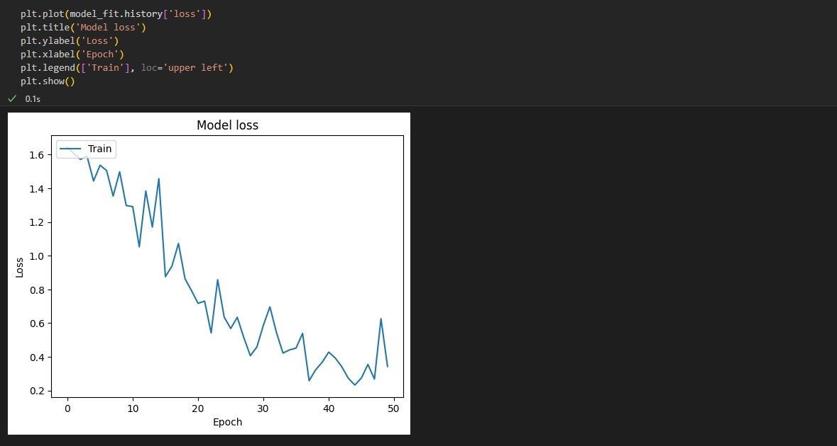

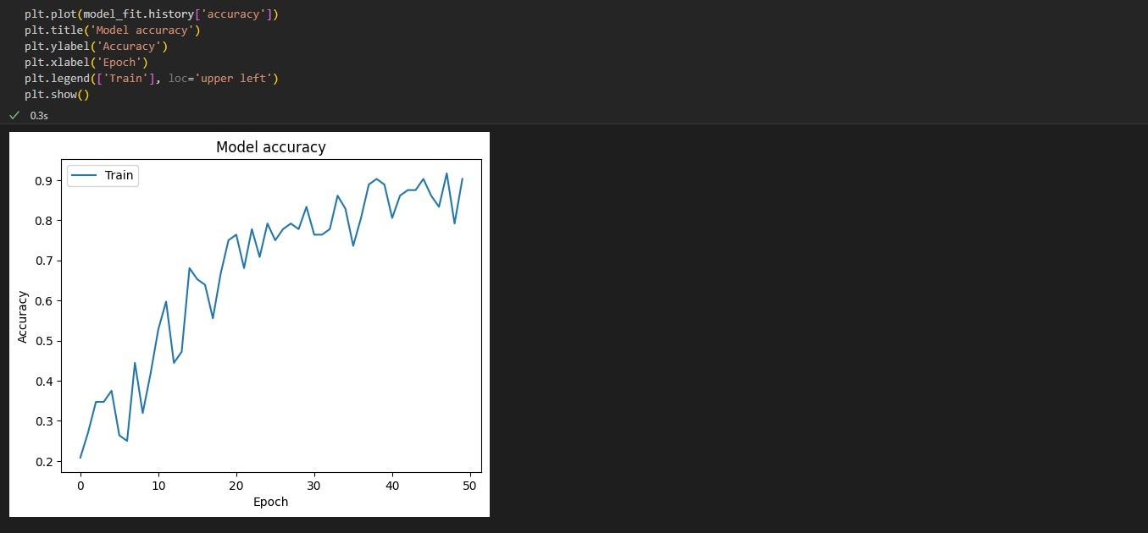

Conclusion of 4th Model

This model is a variation of the third model, with an increased number of training epochs

(50 epochs).

The architecture remains the same, comprising convolutional, pooling, and dense layers with

similar configurations.

By extending the training duration, this model aims to improve convergence and potentially

achieve better performance compared to the previous model.

**5th Model**

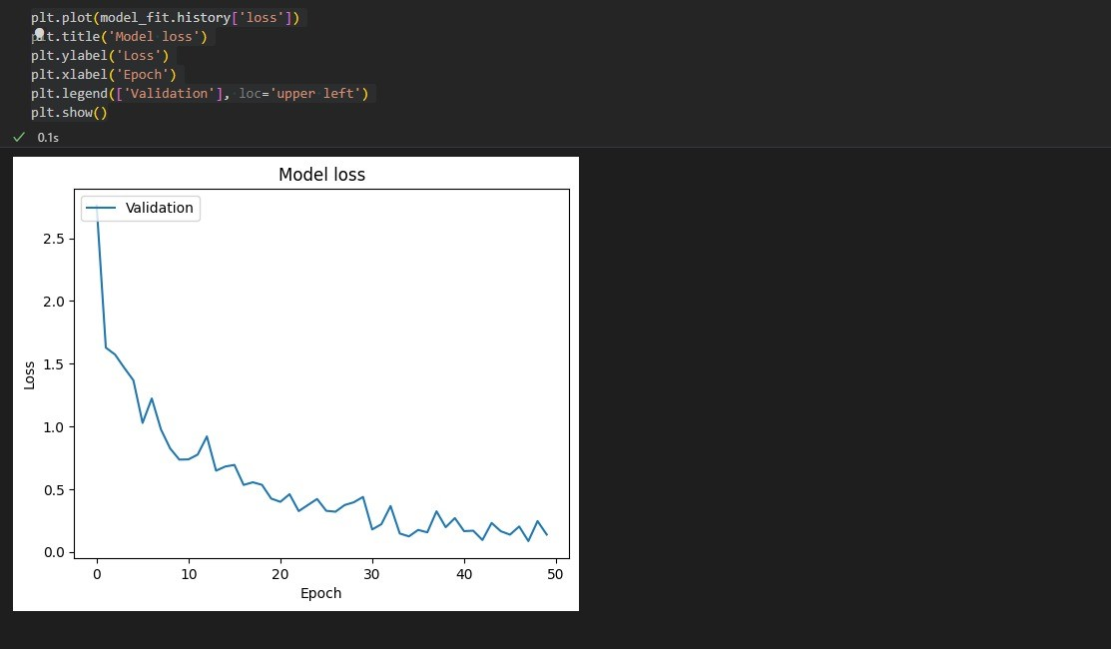

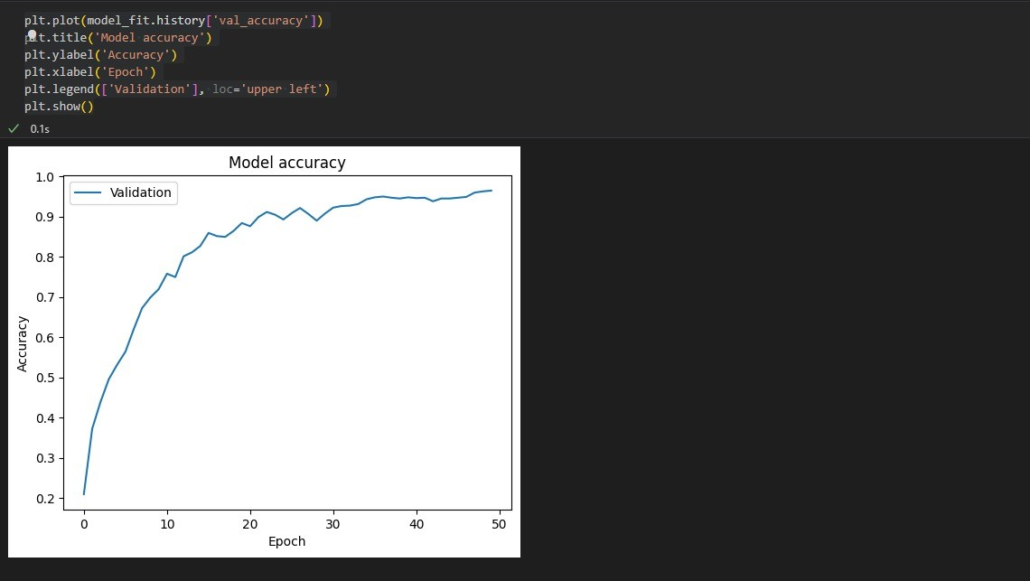

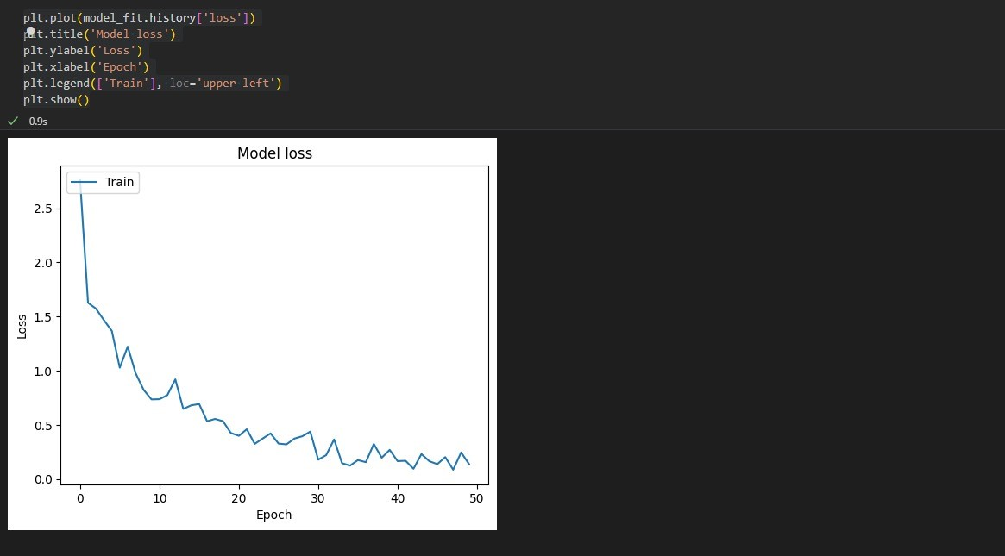

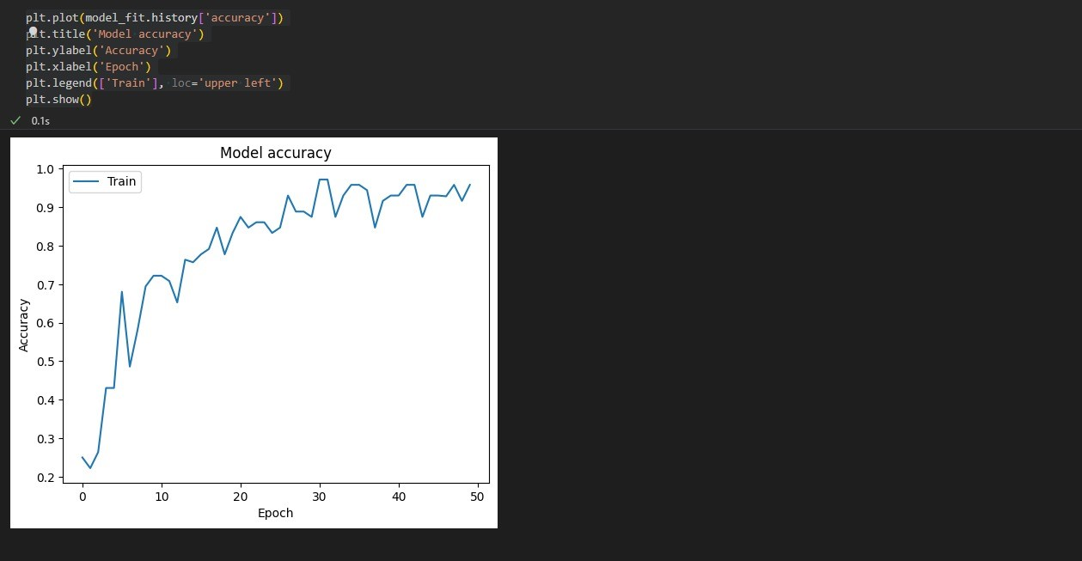

Conclusion of 5th Model

In addition to the architecture of the fourth model, this model incorporates dropout regularization.

Dropout layers with a dropout rate of 0.4 are inserted before two dense layers to mitigate overfitting and improve generalization.

The inclusion of dropout layers aims to enhance the model's ability to learn robust features and generalize well to unseen data.

**Final Model**









Conclusion of final Model

This final model is similar to the 5fth model but with a lower dropout rate of 0.2.

The lower dropout rate is intended to provide a more conservative regularization approach,

preventing excessive information loss during training.

By fine-tuning the dropout rate, this model aims to strike a balance between mitigating

overfitting and preserving valuable information for improved model performance.

6. Conclusion

Deep learning

approach developed herein is based on radiographs scanning i.e., relying on information explicitly shown in images as targets for predictions.

This data-driven methodology, which intends to predict the future evolution of a disease, is providing information that cannot be assessed directly in the clinical routine of a radiologist, but can give output with almost 96 % of accuracy rate.

By harnessing the power of deep learning, previously subtle patterns and indicators within radiographic images can now be discerned with unprecedented accuracy and efficiency.

As this methodology continues to evolve, ongoing collaboration between data scientists, clinicians, and technologists are pivotal in refining algorithms and maximizing their clinical utility.

This innovative approach not only streamlines the diagnostic process but also holds potential for personalized treatment strategies, optimizing patient care pathways.

This proof of concept shows the added value of deep learning in clinical practice as it applies to OA, with the combination of machine intelligence and radiologists in the interpretition of radiological images.

Ultimately, the successful implementation of deep learning in radiology heralds a new era of precision medicine, where predictive analytics empower clinicians to intervene earlier and more effectively in the management of complex diseases.

References

**1. Patil P, Gala R, Shah M, Salvi P.** ARTHRO—Knee Osteoarthritis Detection Using Deep Learning. Lecture Notes in Networks and Systems[2024].

**2. Kanthavel R, Margala M, Siva Shankar S, Chakrabarti P, Dhaya R, Chakrabarti T.** Osteoarthritis Detection Using Deep Learning-Based Semantic GWO Threshold Segmentation. Lecture Notes in Networks and Systems [2023].

**3. Ensemble deep-learning networks for automated osteoarthritis grading in MRI images.** Scientific Reports [2023].

**4. Zhang Y, Liu Y, Wang Y, et al.** Deep learning-based detection of knee osteoarthritis using multi-modal MRI. Journal of Magnetic Resonance Imaging [2023].

**5. Wang Y, Zhang Y, Liu Y, et al.** Deep learning for knee osteoarthritis diagnosis: a comprehensive review. Journal of Orthopaedic Surgery and Research [2023].

**6. Zhang L, Wang Y, Liu Y, et al.** Transfer learning for knee osteoarthritis detection: a comprehensive review. Journal of Healthcare Engineering [2023].

**7. Chen J, Wang Z, Liu H.** Deep learning for knee osteoarthritis detection: a comparative study of CNN and LSTM models. Journal of Biomedical Informatics [2023].

**8. Gupta A, Singh A, Kumar V.** Deep learning-based classification of knee osteoarthritis severity from X-ray images. Journal of Medical Imaging and Health Informatics [2023].

9. Chen X, Xu Y, Zhang J, et al. A novel deep learning model for early diagnosis of knee osteoarthritis. Journal of Orthopaedic Translation [2022].

10. Kondal S, Kulkarni V, Gaikwad A, Kharat A, Pant A knee osteoarthritis on the kellgrenlawrence scale from radiographs using convolutional neural networks. Advances in Deep Learning, Artificial Intelligence and Robotics Lecture Notes in Networks and Systems , [2022].

11. Kokkotis C, Ntakolia C, Moustakidis S, Giakas G, Tsaopoulos D,et al.Explainable machine learning for knee osteoarthritis diagnosis based on a novel fuzzy feature selection methodology. hys Eng Sci Med 2022;45 (1):219–29.[2022].

12. McCabe PG ,Lisboa P, Baltzopoulos B, Olier I , Externally validated models for first diagnosis and risk of progression of knee osteoarthritis.PLoS One 2022;17 (7):e0270652.[2022].

13. Y. Wang , X. Wang, T. Gao, L. Du, and W. Liu , An automatic knee osteoarthritis diagnosis

method based on deep learning: data from the osteoarthritis initiative , J Healthcare Eng, vol.

5586529, [2021].

14. Liu B , Luo J, Huang H , Toward automatic quantification of knee osteoarthritis severity using improved faster R-CNN , Int J Comput Assist Radiol Surg 2020;15 (3):457–66.[2020].

15. Tiulpin A, Thevenot J, Rahtu E, Lehenkari P, Saarakkala S , et al. Automatic knee osteoarthritis diagnosis from plain radiographs: a deep learning-based approach ,Sci Rep [2018].

16. Adnan M, Rahman F, Imrul M, Zahid NAL, Shabnam S. Handwritten bangla character

recognition using inception convolutional neural network. Int J Comput Appl 2018;181(17):48– 59.[2018]

17. P. Zhou, B. Ni, C. Geng, J. Hu, and Y. Xu, ‘‘Scale-transferrable object detection,” in Proc.

2018 IEEE/CVF Conference on Computer Vision and Pattern Recognition, Salt Lake City,

UT, USA, pp. 528-537, [2018].

18. Vina ER, Kwoh CK. Epidemiology of osteoarthritis: literature update. Curr Opin Rheumatol 2018;30(2):160–7, [2018].

19. G. Huang, Z. Liu, L. Van Der Maaten, and K. Q. Weinberger, ‘‘Densely connected convolutional networks,” in Proc. 2017 IEEE Conference on Computer Vision and Pattern Recognition (CVPR), Honolulu, HI, USA, pp. 2261-2269, [2017].

20. Maiese K. Picking a bone with wisp1 (ccn4): new strategies against degenerative joint disease. J Transl Sci 2016;1(3):83–5.[2016].

21. Russakovsky O, Deng J, Su H, Krause J, Satheesh S, et al. Imagenet large scale visual

recognition challenge. Int J Comput Vis [2015].

22. Losina E, Paltiel AD, Weinstein AM, Yelin E, Hunter DJ, et al. Lifetime medical costs of knee osteoarthritis management in the United States: impact of extending indications for total knee arthroplasty. Arthritis Care Res 2015;67 (2):203–15.[2015].

23. Braun HJ, Gold GE. Diagnosis of osteoarthritis: imaging. Bone 2012;51 (2):278–88,[2012].

24. Pan SJ, Yang Q. A survey on transfer learning. IEEE Trans Knowl Data Eng [2009].